**Testing Capital Asset Pricing Model**

The capital asset pricing model (CAPM) is the equation that describes the relationship between the expected return of a given security and systematic risk as measured by its beta coefficient. Besides risk the model considers the effect of risk-free interest rates and expected market return. The Capital Asset Pricing Model (CAPM) is popular amongst financial analysts, however, few devote time to testing its validity. The CAPM is derived from a set of assumptions. It is an abstraction of the real-world capital markets. Although some of the assumptions are unrealistic, they simplify matters a great deal and make the CAPM more tractable from a mathematical standpoint. The CAPM states that, given the assumptions, the expected return on asset is a positive linear function of its index of systematic risk as measured by beta, β, estimated by the following equation:

𝑟𝑖,𝑡 − 𝑟𝑓,𝑡 = 𝛼𝑖 + 𝛽𝑖(𝑟𝑚,𝑡 − 𝑟𝑓,𝑡) + 𝑒𝑖,𝑡

Where, 𝑟𝑖,𝑡 = observed return for asset i for time t; 𝑟𝑓,𝑡 = observed return on risk-free rate for time t; 𝑟𝑚,𝑡 = expected return for the market portfolio for time t; and 𝑒𝑖,𝑡 = error term for time t.

The purpose of the assignment is to test the validity of the Capital Asset Pricing Model (CAPM). In equilibrium, the CAPM predicts that all investors hold portfolios that are efficient in the expected return-standard deviation space.

**PROCESS**

To test the Capital Asset Pricing Model , data from official statistics of the Bombay Stock Exchange is used. Here, we analysed 36 companies and calculated the log returns ,simple returns and betas . We are calculating with reference to S&P BSE 500 for the period of 31 months from April 1, 2018 to September 30, 2020 from Yahoo! Finance. This data may be used as a proxy for the market returns (r m).The data which is used as a proxy for the risk free rate of return is (rf) monthly yields on Government of India 10-Year Bonds for the period of 31 months from April 1, 2018 to September 30, 2020 from Investing.com

Since , we have already done the first part i.e. calculated the log returns on 36 securities and the betas of these securities. A methodology referred to as a two-pass regression is used to test the CAPM. The first pass involves the estimation of beta for each security from its characteristic line. The betas from the first pass regression are then used to form portfolios of securities ranked by portfolio beta. The portfolio returns, the return on the risk-free asset, and the portfolio betas are then used to estimate the second-pass regression. The portfolio returns is simply the mean of individual returns .

Then we run second-pass regression which is the empirical analogue of the CAPM is estimated:

Rp – RF = b0 + b1 βp + ep

where the parameters to be estimated are b0 and b1, and ep is the error term for the regression.

Rp – RF -- Average excess of returns on asset over the testing period ; b0 -- Regression intercept ; b1 regression coefficient; βp  -- Estimated beta of the asset ; ep -- Random disturbance term.

The average excesses of all assets’ returns over the risk-free interest rate will be regressed against their estimated betas.

**RESULTS**

1. Descriptive statistics of the dependent and independent variable.

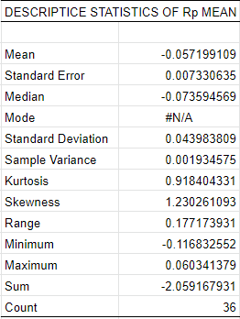 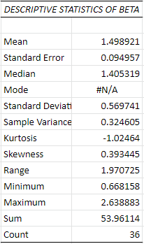

1. Scatterplot with trend line of the dependent and independent variable.

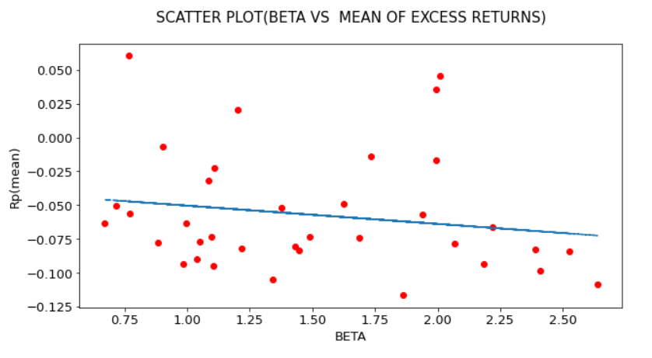

1. Summary of regression results

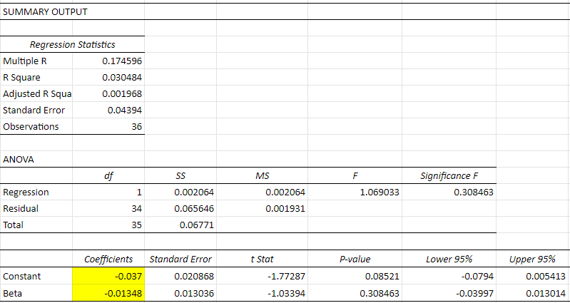

1. State the null and alternate hypothesis

Testing the parameters of the regression equation: b0 and b1

H0 : b0 = 0 V/s H1 : b0  ≠ 0

H0 : b1 = 0 V/s H1 : b1  ≠ 0

Both b0 and b1 have a p-value greater than 0.05. Therefore, we fail to reject the null hypothesis in the both the cases. Analysis shows that b0 is 0 but b1 is not significant.

1. Diagnostic plots

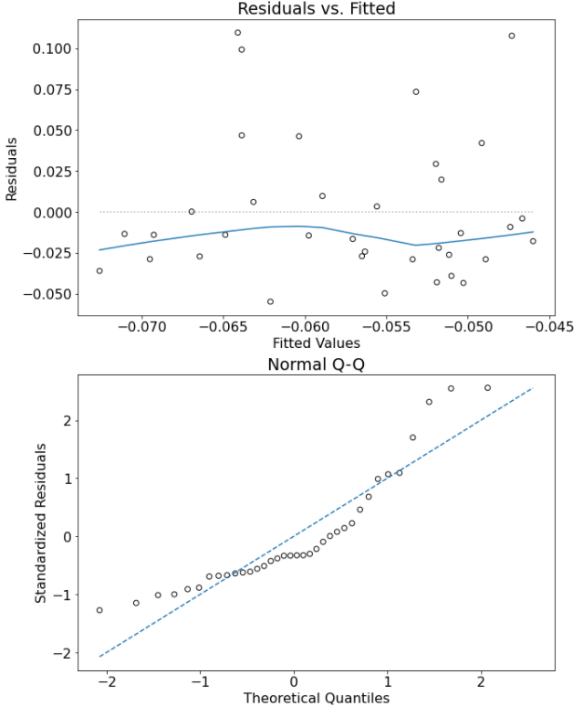

Conclusion:

The estimated Security market line has a downward slope which doesn't supports the idea of CAPM that expected returns are positively and proportionally related to beta.

Also, the line intercept is not 0. However, to draw any constructive conclusion, we must examine regression results. Since, both b0 and b1 have a p-value greater than 0.05, hence, we cannot reject the null hypothesis. Therefore, we can say that b0 is equal to 0 but the slope is negative and not significant. Also, R-square value is extremely low suggesting that only a small portion of variation in returns can be explained by beta. These results don’t support the CAPM.